ASSIGNMENT 6.6:

Write a map reduce program to use Sequence file as input and save the output in key value output format.

Driver Class:

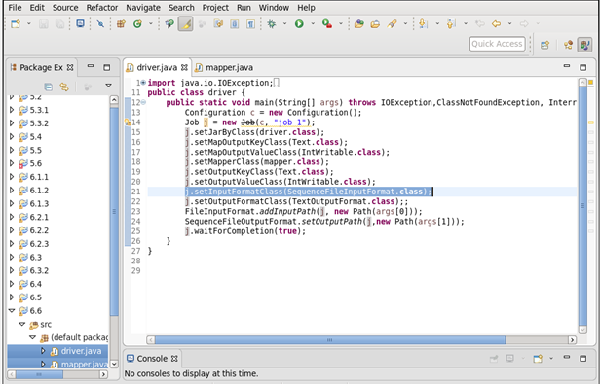

Mapper Class:

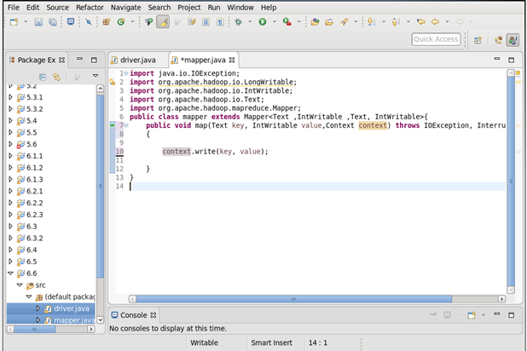

Executing the Jar File with the 6.5 Output :

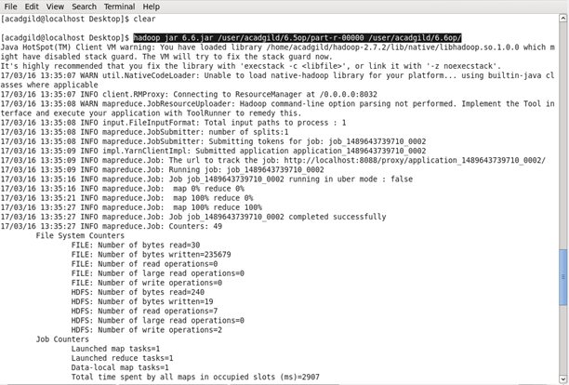

Output:

